Contents

1 Theory 2

2 Use-Cases for Resiliency 3

2.1 1st Discussion: This scenario will help us to envision the importance of resiliency4J pattern. 3

1) Circuit Breaker Pattern 4

2.2 Theory 4

2.3 Status in Circuit Breaker Pattern 5

2.4 Circuit Breaker Advantages 5

3 Architecture 5

3.1 First Discussion 5

4 Implementation 5

4.1 Circuit Breaker Pattern 5

# Theory

1. **Inside microservice network where hundred of microservices are running, anything can happen like** 
   1. One of the services may have Network disruption.
   2. It may behave slow.
   3. It is completely down.

So, for all these failures, your system must be ready by having some resiliency inside it.

1. **Resiliency**: Ability/capability of any entity to come out of any difficult situation.
2. The issues in Challenge 5 (Resiliency)  
   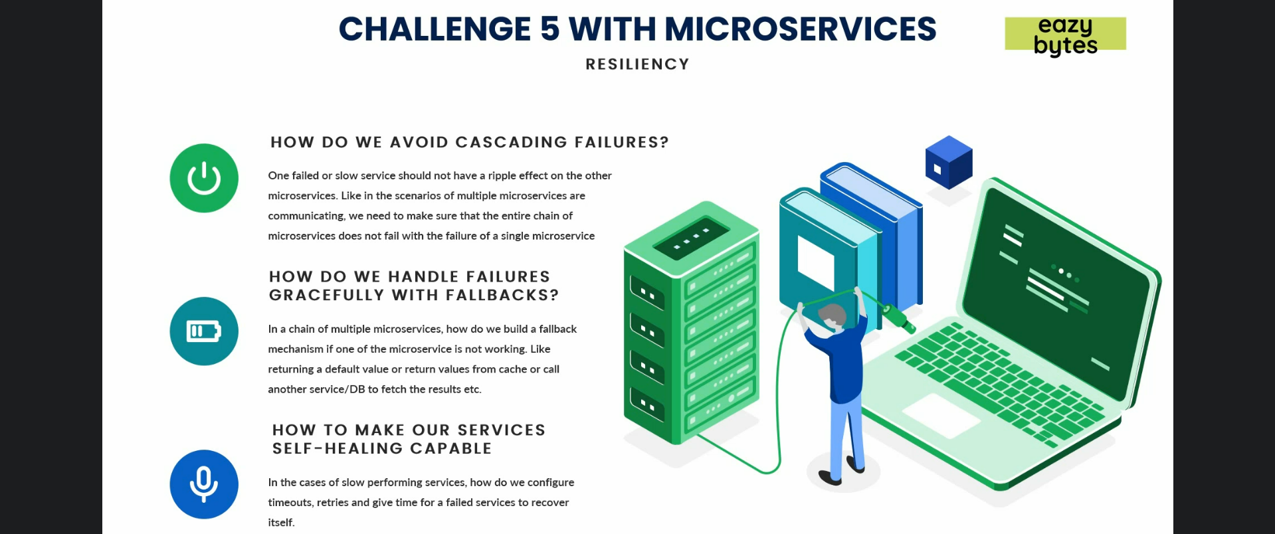
   1. **How to avoid cascading failures inside out network**?
      1. **Situation**: Suppose A, B, C microservices. A calls B and B calls C but C is taking good amount of time to respond back for a request. Clients keep on sending requests from A -> B -> C. We know for each request, a thread is created so the threads in A and B would wait for the response from C. So due to C’s slow response resources (threads) in A and B are occupied. So eventually, A and B will also begin to behave slowly.  
         So to avoid this **cascading failure**, microservice network must have some self healing or resiliency.
   2. **How do we handle failures gracefully with fallback**?
      1. If A->B->C and C is not working at all or not responding within the stipulated time, B must have some fallback mechanism to send some default values, or cached values or values from some service DB.
   3. **How to make our services self-healing capable**?
      1. **Timeout**: How to configure the **timeout** for a microservice up to which a thread from calling microservice has to wait.
      2. **Retry**: If a request fails, how to retry the request.
      3. **Failed Service**: If a microservice goes down, how to stop further requests to that instance and give it some time to recover. Sending more and more requests make that ms more down. So giving some time may help it to recover and play better.
3. Spring Boot and Spring Cloud to over these challenges.  
   Let’s see how they are going to help us with these resiliency challenges inside microservice architecture.

# Use-Cases for Resiliency

## 1st Discussion: This scenario will help us to envision the importance of resiliency4J pattern.

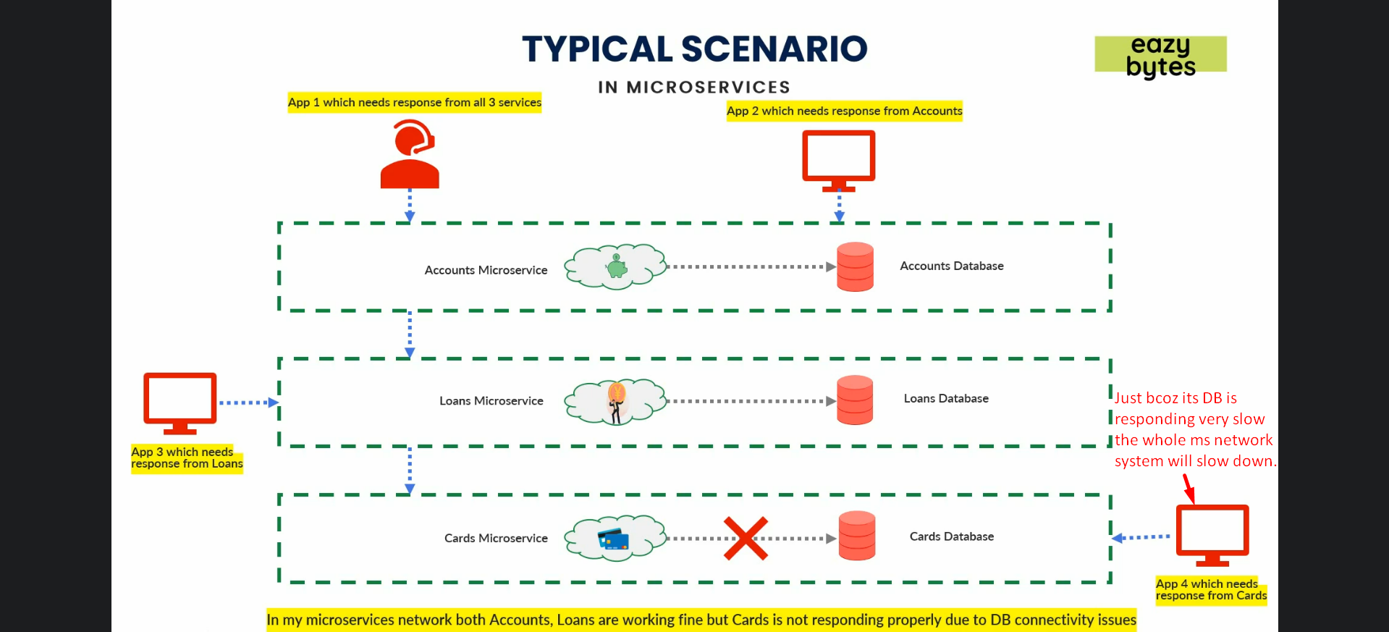

1. We have three microservices 🡺 account, loan, card deployed.
2. There are other applications in our bank invoking these microservices.
   1. Say, we have **customer executive app** where if some bank customer calls my customer executive for any help, he needs the customer details like what accounts, loans cards he has associated with the bank.  
      So in order to know that the bank customer executive will invoke the API exposed on the microservice and that account microservice will further invoke loan API which is exposed on loan microservice followed by card API exposed on card microservice. So, in order for the App 1 to work properly, my all microservices should work properly and collectively with each other and should return collective response.  
      Similarly, we have App 2 which requires info from just account Microservice.   
      App 3 and App 4 require info from loan and cards microservice respectively.
3. Let’s discuss a scenario now.   
   Suppose suddenly card microservice DB starts working slowly so giving response very slowly to your card microservice’s business logic.  
   So App 4 (dependent on cards ms) will respond late now maybe some time timeout issues and   
   As App1, App3 depend on App4 (running slow) will also respond late.   
   If thousands of custom executives are there accessing App1 to hit accounts ms which in turns hit loans, cards microservices too will slow down loans and cards microservices as for each request, thread and other resources are consumed where threads would be waiting for the response and other requests would go in waiting state.
4. If we implement Resiliency4J pattern, in this network, only App1 and App4 will affect not App2, App3 as these two apps are not dependent on cards ms.
5. **One Solution**: We can have some fallback mechanism where card ms can send some default response to account ms whereas loans ms is working fine so in worst case, the user can’t see card information but accounts and loans info.

# Circuit Breaker Pattern

## Theory

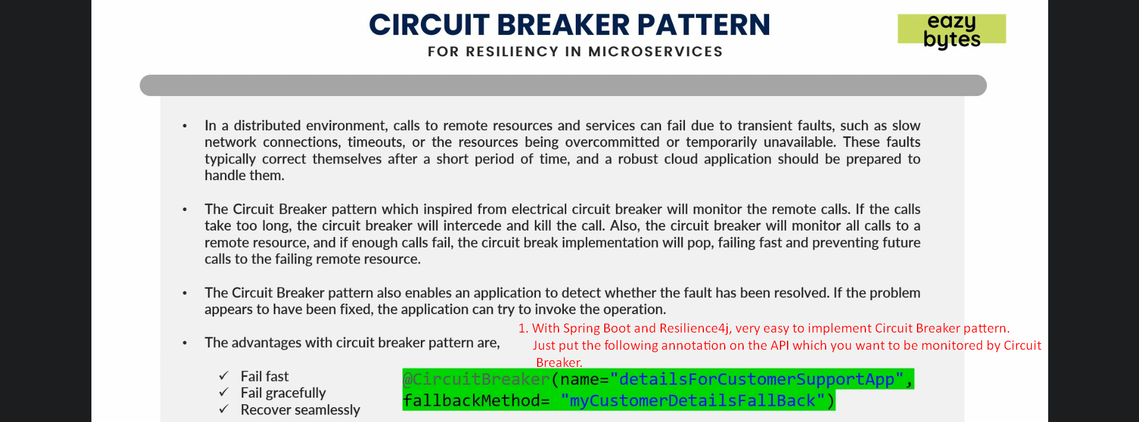

* 1. **Circuit-Breaker pattern** helps us to achieve resiliency (fault tolerance).
  2. This pattern falls under the category of **sustainable design patterns**. That means it helps to keep a particular service alive without failing.
  3. **Terms**: In-Memory calls vs Remote Calls.
  4. Let’s discuss the scenario where it can help us.  
     In **distributed system**, there may be calls to remote services and these services can fail due to  
     🡪 Slow network   
     🡪 Timeout  
     🡪 exhausted resources  
     These faults typically correct themselves after some short period of time.  
     So any robust cloud-based app (ms) should be able to handle such scenario.
  5. This pattern is inspired from electrical circuit breaker. If too much current is passed through a circuit, the circuit will break/open so that no further current will be passed to the circuit which will save other equipment from being damaged.
  6. In software circuit breaker pattern, it will monitor each and every call being made through the circuit. If the call is taking too much time, the circuit breaker will come into picture and kill that call and if such is happening for majority of the calls, it will decide and open the circuit so that no further invocations are happening to the ms where it is behaving slowly.  
     So when circuit breaker opens a network, obviously accounts and loans microservices have to wait till the timeout happens and get response immediately because the circuit is open and at the same time they get some default response that you might configure instead of getting so and so ms is not working properly and circuit breaker is smart enough to decide when to open the network like it will keep on monitoring all the incoming requests and no of failures reaches a particular threshold, it will open the network and makes sure no further request goes to cards ms. So, this way it is failing fast and giving a fast response whether it might be an exception response or default response. So, this way accounts and loans microservices threads don’t have to wait which will save from the throttling scenario on those ms issues.  
     2nd when it is opening cards network, it is giving some time to the cards ms to heal itself.
  7. **Half-opening the circuit**: Circuit breaker is smart enough by half-opening the circuit. Then it will allow only a certain percentage of new requests coming from the App1 and App4. If still requests are getting failed, the circuit breaker will switch to open status (opening the network) otherwise will close the network so that all the requests coming from App1 and App4 can be processed properly. This is continuous process that will happen at the circuit breaker pattern which will save all microservices in our network from the cascade failure scenarios.   
     **Start Lec73, 08:38  
     Circuit breaker will act as proxy on top of your API on which you apply @CircuitBreaker.**

## Status in Circuit Breaker Pattern

1. 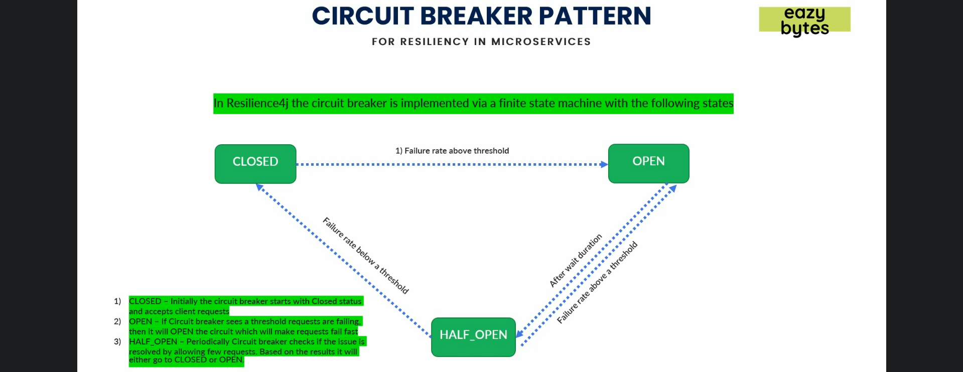

## Circuit Breaker Advantages

* + 1. Failing Fast: Client doesn’t need to wait till timeout happens.
    2. Recovery seamlessly.
    3. Fail-Fast Gracefully.

# Architecture

## First Discussion

# Implementation

## Circuit Breaker Pattern

* + 1. **Add dependencies**: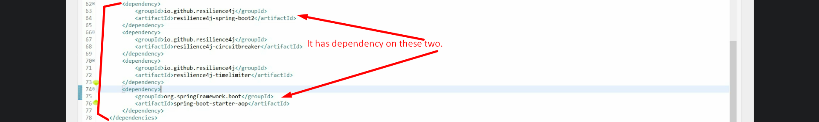
    2. **Add annotation @CircuitBreaker on the API which you want to be monitored by Circuit Breaker.**

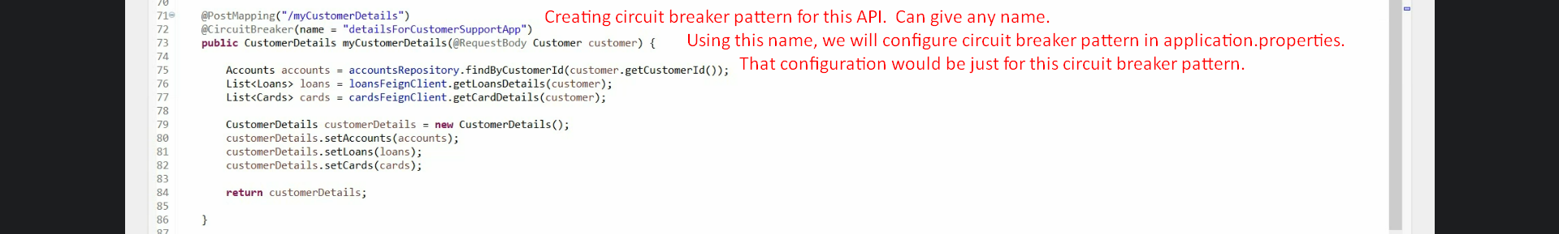

* + 1. **Circuit breaker Configuration in application.properties.**   
       **NOTE**: There is default configuration but you can override them.
       1. 
          1. **Default**: false.
          2. Informing resilience4j to register circuit breaker health related info to the actuator.   
             Following info

What kinds of circuit breakers we have.

Their health.

What state they are into.

* + - 1. 
         1. Minimum how many calls to be monitored after which circuit breaker will take decision about changing the circuit state (Closed, Open, Half Open)
      2. 
      3. 
      4. 
    1. Testing the app.
       1. 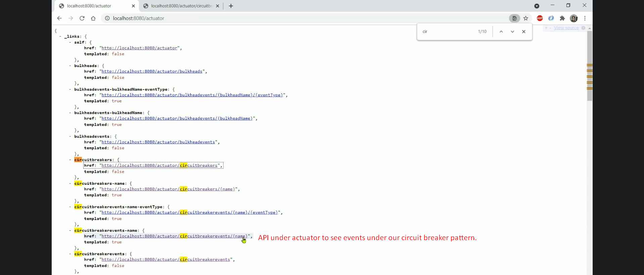
       2. 
       3. 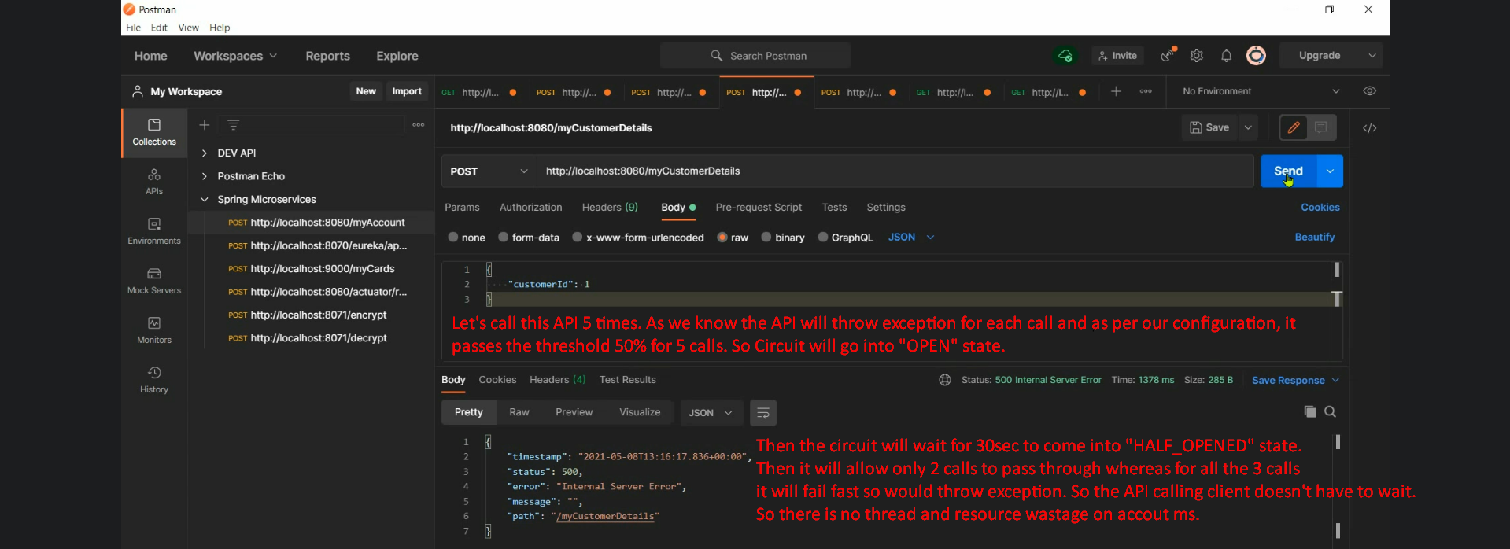
       4. 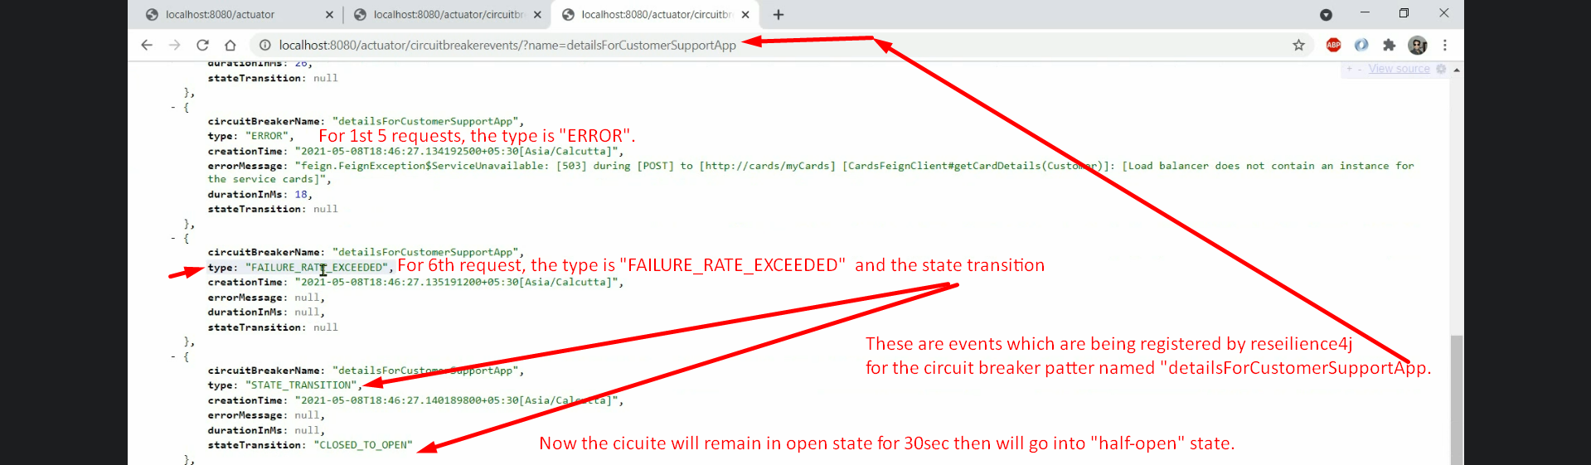
       5. 
       6. Let’s make call after 30 seconds so that our circuit breaker is in “HALF-OPEN” state.
       7. As per our configuration for HALF-OPEN state, now if we make 2 calls, the circuit breaker will go into OPEN state as those 2 calls will fail which exceeded the threshold 50% when the circuit is in HALF-OPEN state. So, further calls will fail fast made in next 30 seconds after going into OPEN state.

## Circuit Breaker with Fallback Mechanism

* + 1. 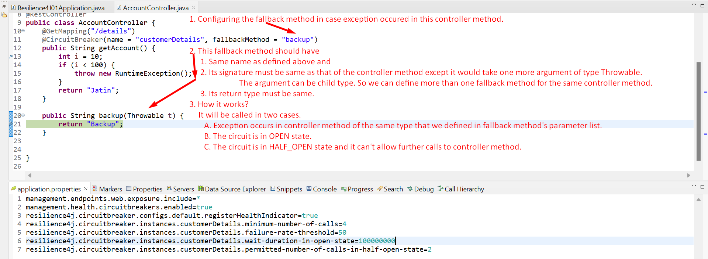

## Retry Pattern

### Theory:

* 1. Another pattern after circuit breaker pattern for resiliency inside our app.
  2. Retry pattern helps us to make multiple retry attempts (based on configuration) in case service is temporarily failed.  
     In environment having 10,000 microservices may have network disturbance. Retry can help to successfully hit a service in further retries.
  3. 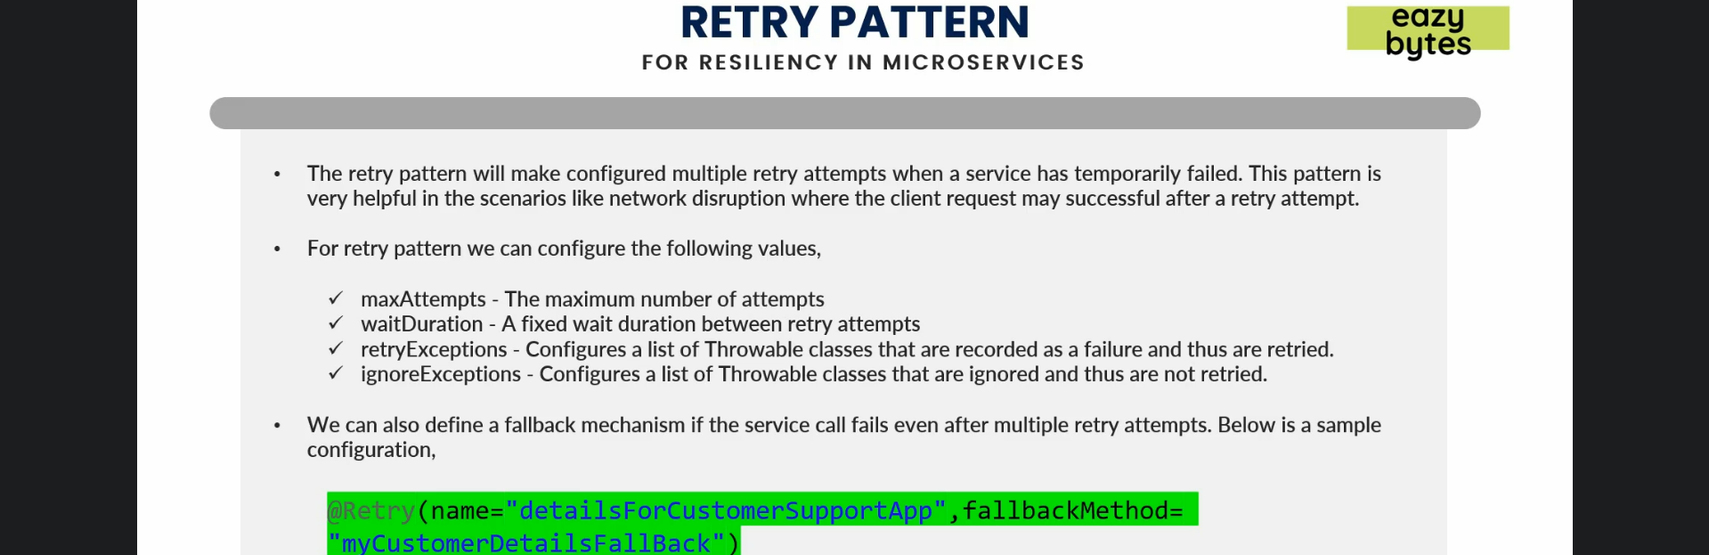

### Retry Pattern Implementation

1. **Add dependency as we added for Circuit breaker**.
2. Configurations in application.properties file  
   
3. **@Retry** 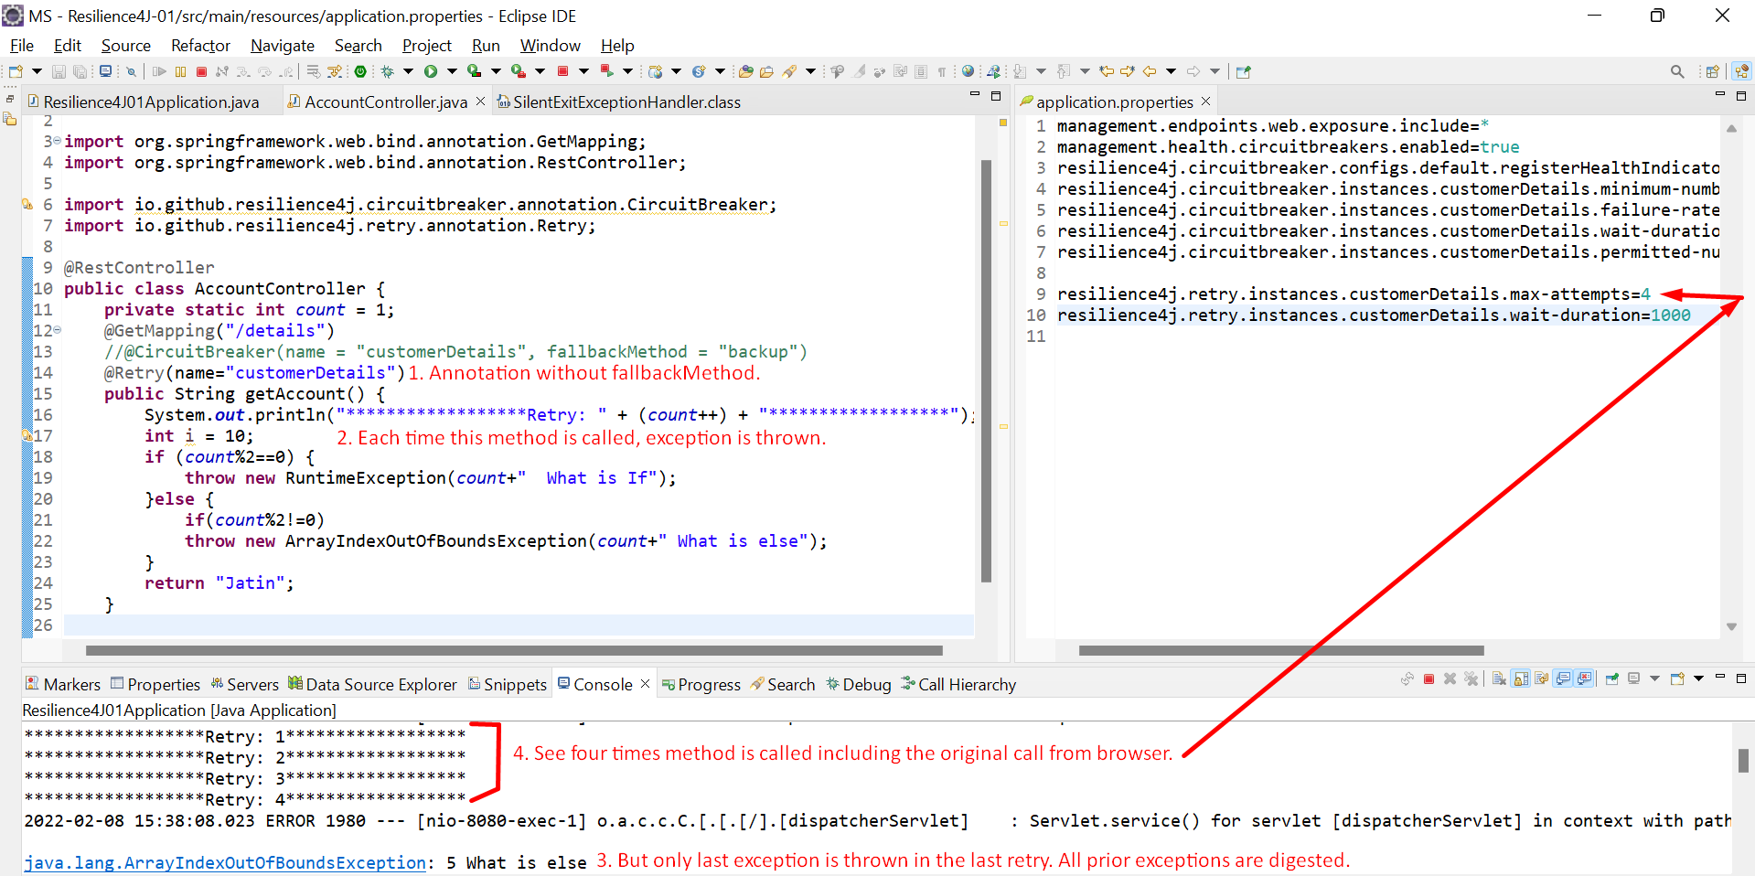
4. What if **fallbackMethod** is configured.
   1. 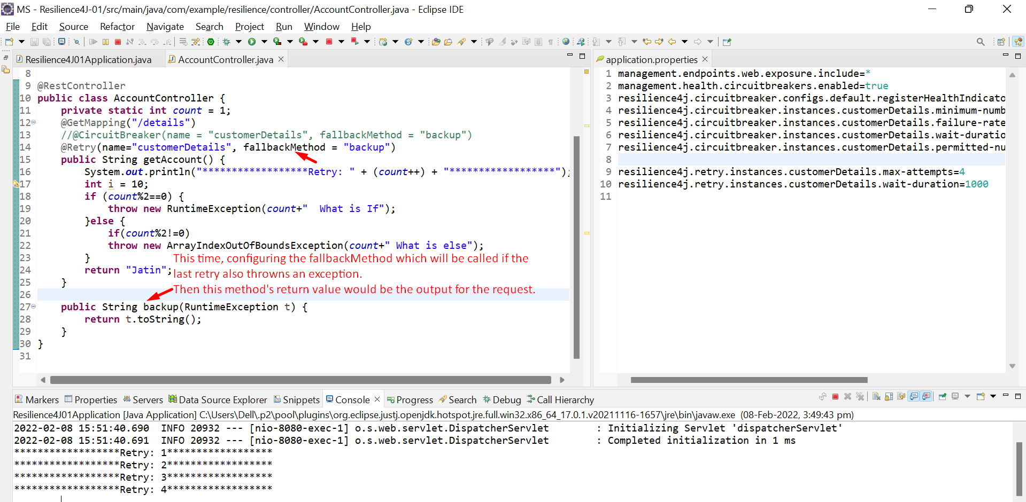

## Rate Limiter/limiting Pattern.

### Theory:

Suppose Service B has an API which is CPU intensive and we know max 5 requests can be executed efficiently within 2min, then we should go for rate limiter.  
Useful to avoid a bulk of requests attacks by BOT, Java Script, some other apps.

* + 1. 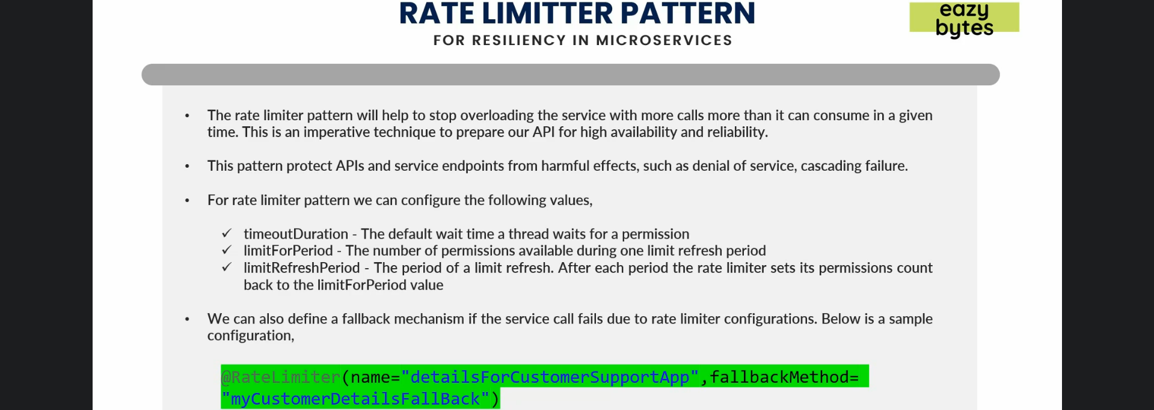

### Implementation

1. **First Implementation**:
   1. **Dependency:** Same as for Circuit Breaker Pattern
   2. **Configurations in application.properties** 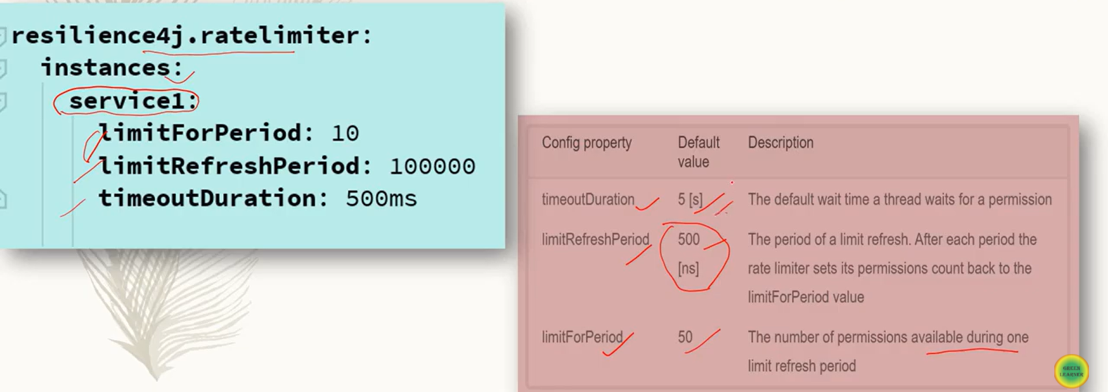
   3. Annotation **@RateLimiter**(name=”<name>”) where name is mandatory.  
      

## Bulk Head Pattern

### Theory

1. This is a resiliency pattern that we can implement in our ms. 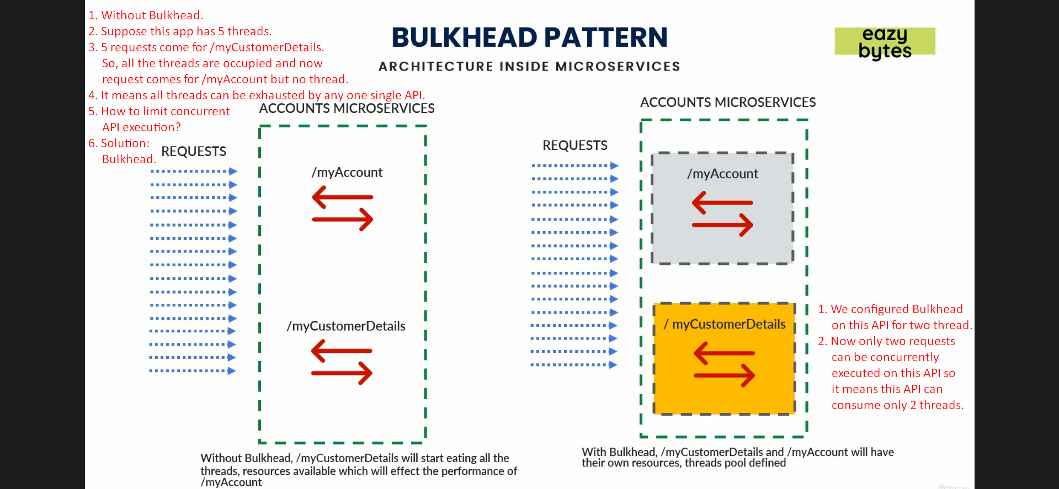
2. 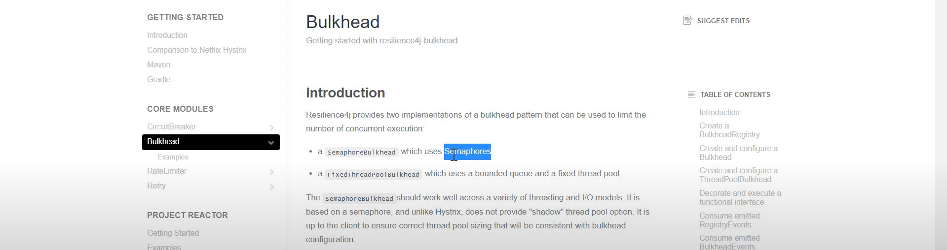

### Implementation

1. Configuration  
   